PMCC:
Membership Information
Benefits of Membership
Why Join? Why Renew?
As the pre-eminent organization focusing on historic postmarks and post office history, the PMCC is an enthusiastic group whose members not only share information but also readily share duplicates from their collection, all to advance each other’s enjoyment of the hobby. The PMCC offers many opportunities to network with other collectors, find answers to your questions, and stay informed about currently available covers and postmarks, as well as historic ones.

Benefits of PMCC membership include:
- An information-packed monthly newsletter
- The latest about our annual convention that scores of members attend
- Access to information from the world’s largest postmark museum
- The only resource for continually updated lists of presently operating U.S. post offices (and other operations with collectible cancellations)
- Ready answers to your postmark and postal history questions
- Numerous opportunities to buy, trade, and send for postmarks
- Discounts on post office directories and other items

Supporting PMCC
As a club, PMCC is most effective when members are highly involved and supportive, advancing both the organization and our world-class postmark museum.

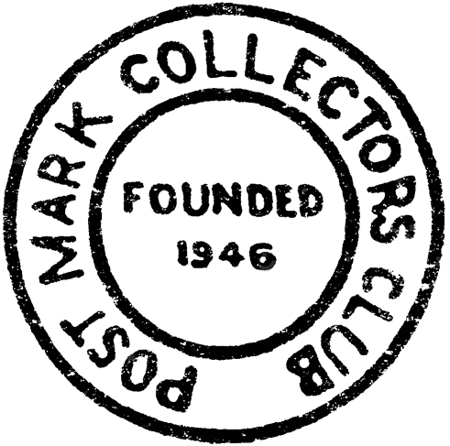
There are many ways to contribute to the organization if you are so inclined. Share your duplicate postmarks with philatelic newcomers or with veterans who share a common interest. Utilize your expertise by answering questions from members and others to advance interest in our hobby. Contribute articles to our Bulletin, or submit the latest news about post office openings, closings, and changes for the PMCC Post Office Directory. Donate extra material to the museum or for use at the annual convention.
Financial donations are, of course, most welcome! Money goes toward maintaining our ever-expanding Museum, our award-winning Bulletin, and our club outreach activities. The PMCC is a 501(c)(3) nonprofit organization, and donations are tax-deductible.

Membership Rates

All membership tiers provide the same benefits. Please select the membership level that reflects your desired support for the PMCC.
Standard $20
Sustaining $35
Benefactor $50
Full-Time Students and/or Under 18 $10
Associate Members $10
18 or over with full-time paid member
in same household; Bulletin is shared
- Bulletins are mailed by USPS Marketing Mail, though U.S. members can request First-Class delivery of their Bulletin for an additional $18 per year.
- A full-color Bulletin also is available by e-mail, in addition to, or instead of, the mailed version for no extra charge.
Foreign rates are the same as shown, in U.S. dollars.

Regional Chapters
PMCC currently has two active Chapters, each of which focus on the postal history of their areas, hold get-togethers, and offer opportunities to discuss regional postmarks in more depth. The Chapters are a great source for community building. In addition to PMCC membership, if a chapter sounds of interest, please send your name and address, plus dues, to the contact person listed — or simply check the box on the next page and include your chapter dues with your regular dues.
New England: Quarterly newsletter; $5 annual dues.
Kelvin Kindahl
Kelvin01027@gmail.com
267 Locust St Apt 2E, Florence MA 01062-2059
Colorado: Quarterly newsletter; $5 annual dues.
Bill German
pmcceditor@gmail.com
257 Mockingbird Circle, Lexington SC 29073-7709

PMCC:
Membership Form
Thank you for supporting PMCC!

NAME:
Please check all that apply:
MEMBERSHIP
□ Standard $20
□ Sustaining $35
□ Benefactor $50
□ Full-Time Student or Under 18 $10
□ Associate (shared Bulletin) $10
MAILING
□ Bulk-mailed Bulletin (included)
□ First-Class-mailed Bulletin $18
□ E-mailed Bulletin (no charge)
CHAPTERS
□ New England $5
□ Colorado $5
DONATION
□ Additional donation (thank you!)
Total Enclosed:

Please check all that apply:
□ Regular Membership $20
□ Sustaining Membership $35
□ Benefactor Membership $50
□ Full-Time Students or Under 18 $10
□ Associate Member (shared Bulletin) $10
□ Bulk-mailed Bulletin (included)
□ First-Class-mailed Bulletin $18
□ E-mailed Bulletin (no charge)
□ New England Chapter $5
□ Colorado Chapter $5
□ Additional donation (thank you!)
Total Enclosed:

ADDRESS:

E-MAIL:
OCCUPATION:
PHONE:
PROPOSED BY:
DATE OF BIRTH:
Collecting preferences:
(See complete preferences abbreviation list at
http://www.postmarks.org/members/pref.pdf
... or simply list what you collect!)

Other club memberships / interests:

Please sign: Date:
Please mail check payable to PMCC and completed application form to:
Doug Carlson, Membership Director
Postmark Collectors Club
PO Box 191051
San Francisco CA 94119-1051
Internal use only:
Membership Number:

